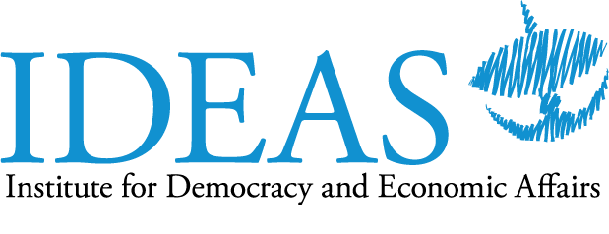

The Issues and Challenges
of Tackling Corruption in Malaysia

Saturday, 6 August 2016
Majestic Riverside Hotel, Kuching

Tentative Programme
(subject to change)
Time | Item
0900 – 0930 | Arrival and Registration of Participants
0930 - 0940 | Welcome Remarks  Tricia Yeoh  Chief Operations Officer  Institute for Democracy and Economic Affairs
0940 - 1040 | Strengthening and improving the effectiveness of the Malaysian Anti-Corruption Commission  Shaza Onn  Institute for Democracy and Economic Affairs  Pursuing Corruption Cases through the Malaysian Legal System  Dato' Sri Haji Zakaria Bin Haji Jaffar (confirmed)  Former Deputy Commissioner, Malaysian Anti-Corruption Commission (MACC)  Empowering communities to promote good governance  Ann C.j Teo (confirmed)  President, Rise of Sarawak Efforts (ROSE)  Moderator  Tricia Yeoh
1040 – 1200 | Discussion
1200 | Refreshments  End of programme

